
Procedure 2025

ArcelorMittal Building Solutions France Procedure 1.1.1.0

BEST PRACTICES IN CUSTOMER CREDIT MANAGEMENT

Table of contents
A. Credit insurance 4
B. Payment methods 7
C. Terms of payment 7
D. Coding 8
E. Batch QN 9
F. Proforma settlement 10
G. Payment guarantees 11
H. Manufacturing listing 12
I. Shipment listing 12
J. Collection method 13
K. Glossary 15

SCHEMA RECAP: GLOBAL PROCESS

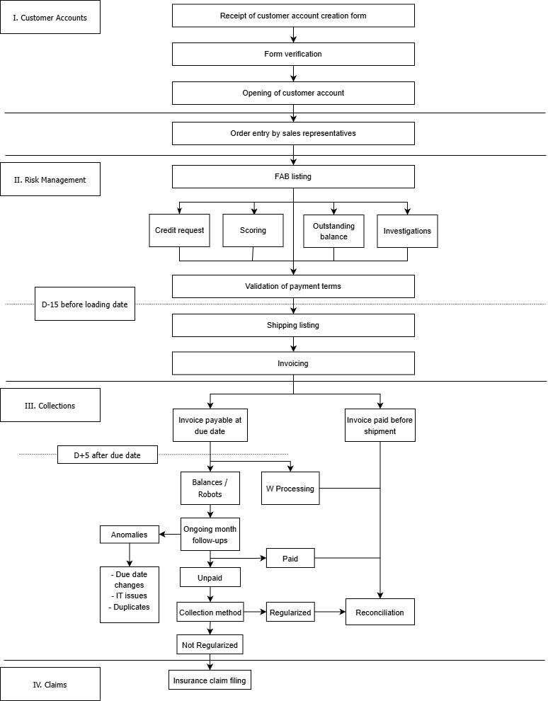

Credit insurance

It's important to bear in mind that consulting these insurances may take some time before a decision is reached on a case.
So the earlier we look at a case, the more time we have to find solutions to support sales reps with their orders.

- ATRADIUS : main insurance company consulted first
(The minimum amount to be requested is 16K€ VAT exlud. (5K€ for the folding activity).

- ALLIANZ TRADE: after studying the file, this secondary insurance should be consulted to compensate for the insufficient credit granted by Atradius.

- Complementary Private Insurance (CAP): can be used to supplement the main policy for which we have already obtained the maximum authorized. As the cost is higher than for the main policy, no late payments or overdrafts will be authorized.

- Complementary private insurance (CAP+): can be used to obtain a line of credit for customers for whom we have not been able to obtain cover under the main policy. As the cost is higher than for CAP, no late payments or overruns will be authorized

- Internal credit (AMBSF): Amount granted according to the credit matrix, with the agreement of the credit manager and validation by the credit committee. An internal credit may be considered depending on the customer's history, recent financial information obtained, regularity of payments, etc.

- CAPTIVE (AMBS): Group insurance that can complement a main policy. The amount granted is determined by the credit matrix

Credit matrix

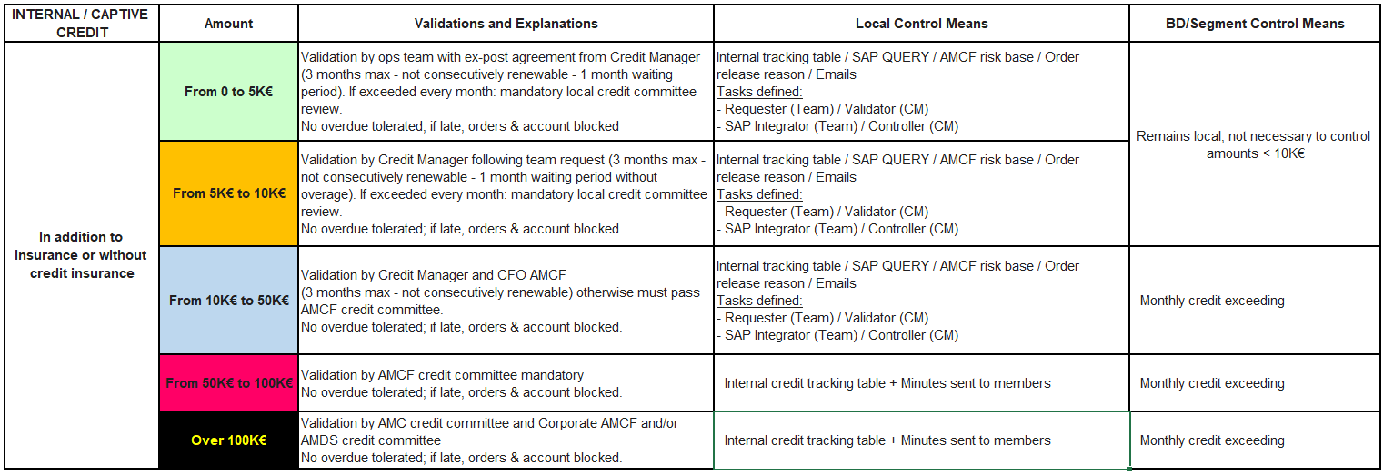

RECAP DIAGRAM: CREDIT APPLICATION

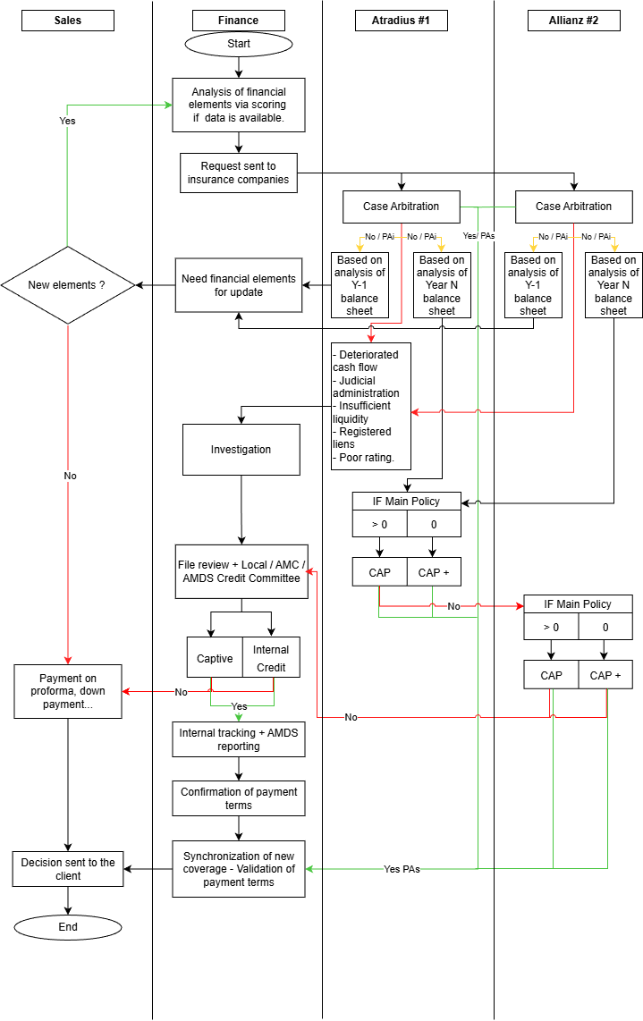

Payment methods

  - Bank transfer: the most frequently used payment method

  - Cheque: only accepted for customers with a Sofie account already exist. However, it is advisable to use bank transfers (faster and no risk of non-payment, unlike cheques).
(Cheques are no longer accepted for orders entered in miscellaneous accounts)

  - Promissory bill: document drawn up by the customer and serving as payment for remittance to the bank by our accounting department.

  - LCR accepted: document drawn up for each due date by our accounting department, which the customer must complete and sign before sending it to the bank.

  - Direct LCR: invoices paid by direct debit on the due date
To set up a direct LCR, it is essential to obtain the customer's agreement by having him complete the direct LCR protocol + Secure a copy of the Banking coordinats.

Terms of payment

  - Pre-production transfer: requested when the customer does not have a line of credit with one of our credit insurers

  - Invoice receipt: due date 15 days after invoice date
→ Example: invoice dated February 12th = due date 02/27

  - 30 days end of month: i.e. due on the 30th or 31st of the month following the invoice date
→ Example: invoice of February (regardless of the fortnight) = due date 03/31

  - 45 days end of month: the due date differs according to the fortnight
→ Example: Invoice dated 05/02 = due date 31/03 Invoice dated 19/02 = due date 30/04

Coding

Each system has its own codification for payment methods and conditions :

Payment method | SOFIE | SAP
Bank transfer | VI | T
Foreign transfer | VJ | F
Group transfer | VG | H
Promissory bill | BO | B
Draft on acceptance | TR | N
LCR direct to bank | TN | S

Terms of payment | SOFIE |  |  | SAP
Terms of payment | Start of due date | Term | Due date | SAP
Before production | 0 | 000 | 00 | U023
On receipt of invoice | 3 | 000 | 00 | U 026
30 days end of month | 5 | 030 | 00 | U 030
30 days end of month on 15th | 5 | 030 | 15 | U 034
45 days end of month | 4 | 045 | 99 | U 046

SAP coding will be necessary when you validate a QN form for account opening or to understand the code noted in SAP if you need to check the customer's payment method or conditions

Batch QN

K / Customer credit / QN Batch → QN Batch follow-up

This file is made up of several tabs:
→ ODC: List all information regarding the account opening form:
- QN file info (A-B): month concerned and file no
- Customer info (C-D-E-F): Sofie code assigned, AX code if folding, customer name, department
- Credit info (G-H): Atradius no. (required) and Allianz no. (if requested)
- Sales info (I-J-K-L): itinerant code, sedentary code, internal activity, AMBSF site
- Financial info (M-N-O-P): amount of credit obtained, date obtained, Sofie conditions, SAP code for payment conditions
- Validation (S): date QN form is validated and sent to SSF (accounting)
- Comments (T): if a credit application is in progress, if it concerns a recent company, or any information relating to the ODC
- Integration (U-V): date of integration into Sofie via menu 03/01/05/08 and SAP number assigned
- Synchronization: date on which the credit was synchronized in SAP (first link must be made with Atradius, and with Allianz if a request has been made)
- Verification (X): Verification of ODC-related data by the CM, from customer account creation to credit synchronization

→ AGENCIES: lists all information concerning the creation of agencies:
- Creation (A): month in which the agency was created
- Customer details (B-C-D): Sofie code assigned, company name and department
- Sales information (E-F-G-H): itinerant, sedentary codes, internal activity, AMBSF site
- Billing and master customer (I-J): Sofie code for billing and master customer (credit)

→ MODIF ECH: lists deadline modification requests:
- Form infos QN (A-B): month concerned and form no.
- Customer data (C-D-E): Sofie code, SAP code and company name
- Data to be modified (F-G-H): current due date, requested due date, amount (incl. VAT)
- Reasons (I): you must justify your request (computer error, billing at the end of the month but delivery the following month, extension granted by the CM, etc.) by means of a document
proof of delivery (approval e-mail from CM, BL to justify delivery the following month, etc.).
- Validation (J): form validated by the CM or rejected if anomalies
- Integration (K): due date change made in SAP
- Control (L): CM checks that new deadlines have been properly integrated

In the first "Tables" tab, you'll also find the various info lists used to automate certain data in the other pages.
For example:
- For sales representatives, the site and internal activity are automatically completed with the sales representative's name.

- For SAP payment conditions, they are automatically filled in with the completed Sofie conditions.

This file ensures that the department is monitored throughout the various stages of the process. It also enables the CM to carry out regular checks and ensure compliance with the procedures in place.


The file must be kept alive. In other words, the tables need to be regularly updated if new people join the company, or if there are changes within the organization (commercial, concerning terms and methods of settlement).

Proforma settlement

In the event that we are unable to obtain credit for a customer, orders must be paid for before shipment, in accordance with the following conditions:

Order value > €5,000 incl. VAT :

    - Deposit of 30% of order to be received for manufacturing release
    - Receipt of balance by bank transfer for dispatch release

Order value :
    - Waiting for customer approval or bank transfer advice to release production
    - Receipt of order transfer for dispatch release

Funds must be received in full before shipment can be released, so customers must anticipate their payments
No payment by cheque will be accepted for customers with no credit or for miscellaneous accounts

Payment guarantees

Imperfect payment agreement

For large projects, or when the customer does not have the cash to pay for an order, it is possible to set up an imperfect payment agreement between AMBSF, our customer and the end customer (the payer).
First of all, we'll need to check the creditworthiness of the end customer and the possibility of obtaining credit cover for him.
If credit is granted on the payer, orders can then be settled at 45J FDM. Otherwise, the payer must pay for the goods by bank transfer before shipment.
Our customer must then complete our agreement model, signed by all 3 parties in 3 original copies, or signed via Docusign.
A copy with the 3 signatures will enable us to release the production of the orders concerned. Upon receipt of the original, shipments can be released. If the customer has no credit, shipments will be released on receipt of the bank transfer.

We only use our agreement model; any other model will be automatically refused, except in exceptional cases and by agreement with CM (general company, group, public, etc.).

Joint bank guarantee and other guarantees

The bank guarantee is a contract committing our customer's bank to pay us, stipulating the amount and the date until which the guarantee is valid.
This bank guarantee contract must specify the maximum amount accepted and the duration of the commitment.
The bank will then block the defined amount on our customer's account until a certain date.
In the event of non-payment, the bank will take the necessary steps to reimburse the sums due. Joint and several bank guarantees only apply to French customers
For foreign companies in Europe, this is known as a Bank Guarantee
documentary credit, known as CREDOC.

Manufacturing listing

The production listing (procedure 1.1.1.14) is processed every morning and lists all orders blocked in production for all activities combined (excluding folding, ERP AX).
Orders are blocked when credit is exceeded or when there is no credit available for the customer concerned.
In order to avoid these blockages, it is necessary to come back to us to anticipate your needs for increases in line with orders that are about to be booked.
As a reminder, consulting an insurance company can take several days, especially if we receive a refusal and have to go to our second insurance company, or if you have to go back to the customer to obtain their latest balance sheet.
For proforma customers, it will be necessary to request a "bon pour accord" for orders under €5,000 inc. VAT, and a deposit of 30% of the order if the amount exceeds €5,000 inc. tax

Shipment listing

The shipment listing is processed from Monday to Thursday and lists orders blocked for shipment within 15 days of the loading date.
The system automatically processes these orders in accordance with financial rules. If the release criteria are not met, such as non-payment of overdue amounts or the month's due date, or non-receipt of the order transfer for customers without credit, the orders remain blocked in shipping and appear on the shipping list
For customers with credit, it is important to know the reason for non-payment (dispute, for example), or whether payment is in progress (amount + method of payment + payment date).
For customers paying before dispatch, it's important to bear in mind that we need to have received the transfer on account before we can release the funds; a notice of transfer will not suffice.
Consequently, the transfer should not be made 2 days before the loading date, but as early as possible. It is up to the sales representative to inform the customer.

If an order is scheduled for loading more than 15 days before the loading date, it will not appear on the exp listing. It will be processed when it arrives within this 15-day period.
Similarly, if no lead time is indicated on an order, it will not appear on our listing and will therefore not be processed.
Once processed, the listings will be sent to the generic mailboxes of each site + certain managers and itinerants (contact group to be updated as needed).

Collection method

Customer reminder
This application represents a shared means of communication with sales staff concerning invoices and due dates for each customer (whether overdue or not).
It is essential to note any information you have concerning real and serious reasons for non-payment or reminders made (dispute, reminder made, information, etc.).
(Procedure 1.1.1.12)

Telephone reminders
Customer credit telephone reminders generally begin around the 20th of the month.
We call a whole list of customers concerning the month's due date which has not yet been paid (in descending order, i.e. from the largest amount due for this due date to the smallest).
(Procedure 1.1.1.12)

Paper reminders
A first paper reminder is sent to customers (whose due date has not yet been paid), and can be edited from the 21st of the month (6 days after the 15th).
A second reminder is sent at the beginning of the month, around the 8th of the following month, for customers still in arrears.
For your information, these reminders are subject to a collection fee of €40 per unpaid invoice
unpaid invoice (LME law)
(Procedure 1.1.1.13)

Registered mail
If payment is still not received 30 days after the due date, registered letters will be sent to the customer (formal notice).
In the first instance, if we are unable to obtain any information from the customer (who does not respond to e-mails or telephone calls, or to sales representatives), a formal notice will be sent in order to initiate a dialogue and, in the best-case scenario, obtain payment.
In a second phase, if the case still remains unresolved within a month, we will send a notice of summons stipulating collection and handling costs.
In the absence of payment or payment proposal from the customer within 10 days, we will have to declare the case to our credit insurance.

Insurance declarations

If all our collection efforts have been in vain, the case will be declared to our credit insurance company, which will result in the loss of credit cover with all suppliers, additional costs, etc.
The collection of our debt will then be declared to our insurance company
Until the case is settled, we will not be able to work with the customer again, unless the credit manager agrees.

RECAP DIAGRAM: COLLECTION
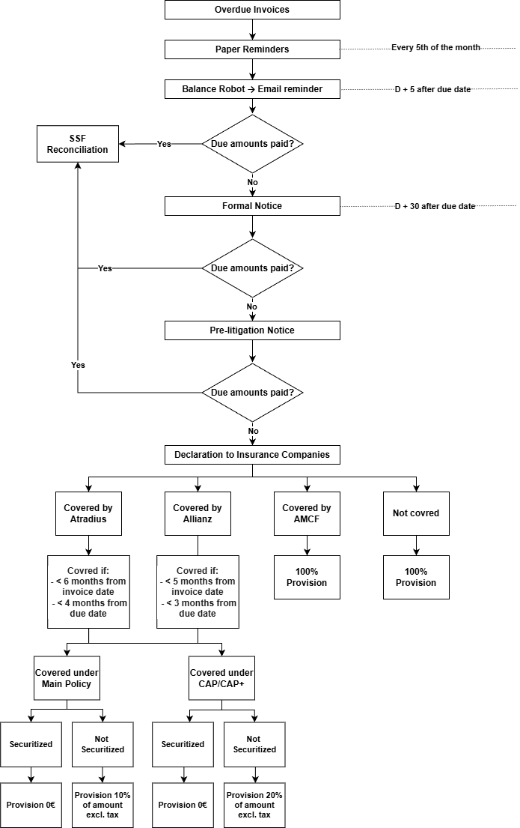

Glossary

QN: Abbreviation for Qual'Net, the website used mainly to open accounts.
Demat: Invoice dematerialization, which means that the customer receives the original invoices directly to the mailbox he/she has previously communicated to us (when opening an account or via an e-mail request).
EDI : Electronic Data Interchange. This electronic format enables commercial documents to be sent from one computer application (or platform) to another.
FAB : Abbreviation for manufacture (fab block, fab listing).
EXP : Abbreviation for shipment (exp block, exp listing).
Overdue: Invoice or sum that has exceeded the specified due date, in arrears.
Doubtful: These are customers reported to our credit insurers following substantial late payments.
Batch: File containing information about a system, an environment or a specific request. For example, our QN batch file contains information on account openings (name, ATRA number, payment conditions, etc.), branch creations and due date modifications.)
ODC : Account Opening
CM : Credit Manager

On: 16/10/2025
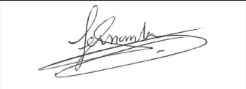
Procedure validated by : S. HERNANDEZ

